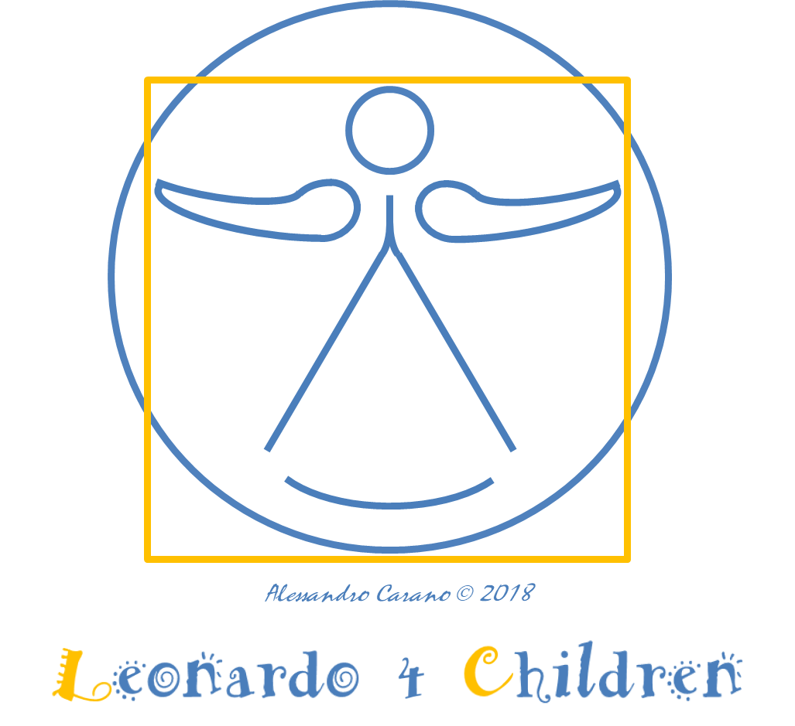

Leonardo 4 Children 2023: Talent Development Programme
Dear winner(s),
As your work is among the winners of the “Leonardo 4 Children 2023 Awards”, we are pleased to offer you access to the Talent Development Program, to allow children and teenagers with high potential in Art & Science to further develop their talent and skills.

We offer to the winners a budget of € 300 (winners 1-3) / € 200 (winners 4-10) to be used for one or more of the following activities:

- Training or workshops in art & science, in presence or online;
- Visit to art or science location and/or meeting with experts in art & science;
- Material for art & science education.

- This form should be completed, signed and sent to leonardo@carano4children.org by 30 September 2023.
- The proposal is subject to approval of the Carano 4 Children foundation within 30 days from its submission.
- The activity should be completed by 30 June 2024.
- The foundation will refund the applicant on the basis of a summary report of the activity and the learning of winners, including media evidence of the activity performed (pictures/videos) and invoices of all the costs incurred, within 30 days from their submission.

Category (Fables, Art & Science)
Title of the winning work
First name, Last name of the applicant
Role of the applicant | parent, teacher, other (pls specify)
Email of the applicant
City, country
First name, Last name of the winners who will benefit from the Talent Development Programme
Description of the proposed activity (material, training/workshop, visit to art & science location, meeting with experts, other - please specify) | between 5 and 20 lines
Description of the expected benefit of the activity for the winners in terms of talent development
Date and location of the proposed activity
(if online, pls specify)
Is the activity related to both Art & Science ? | Yes  No
Is the activity related to Climate, Equality and/or Peace (please specify which one) ? | Yes - Climate  Yes - Equality  Yes - Peace  No
Estimated cost
(max € 300 for winners 1-3, € 200 for winners 4-10)
Bank coordinates for the reimbursement of the costs | Name  Address  Bank account IBAN
Authorisation of the legal representatives of the winners to publish the pictures/videos related to the activity on website and social media of Carano 4 Children foundation ? | Yes  No

Date and location Signature of the applicant

